**Java Strings**

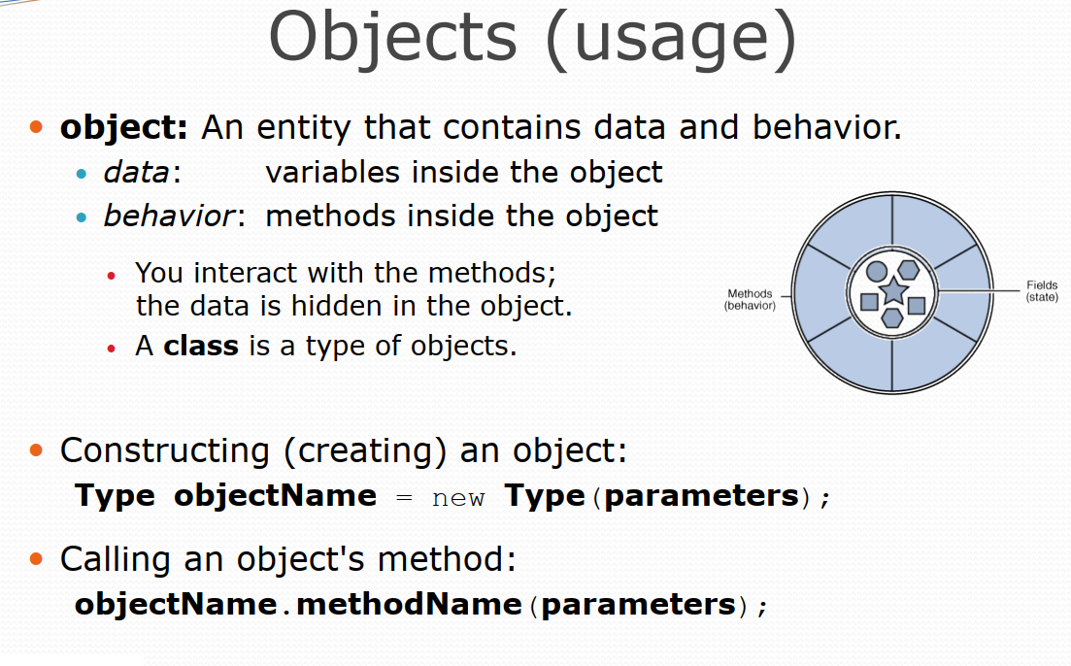

• Java string is a sequence of characters. They are objects of  
type String.

• Once a String object is created it cannot be changed. Stings  
are Immutable.

• To get changeable strings use the class called StringBuffer.

• String classes are declared final.

• The default constructor creates an empty string.  
String s = new String();

